Naveen Kumar Buddhala (001582394)

**Big-Data Sys Engr Using Scala**

**Spring 2021**

**Assignment No. 6**

**Unit Tests**

**MonadOpsSpec**

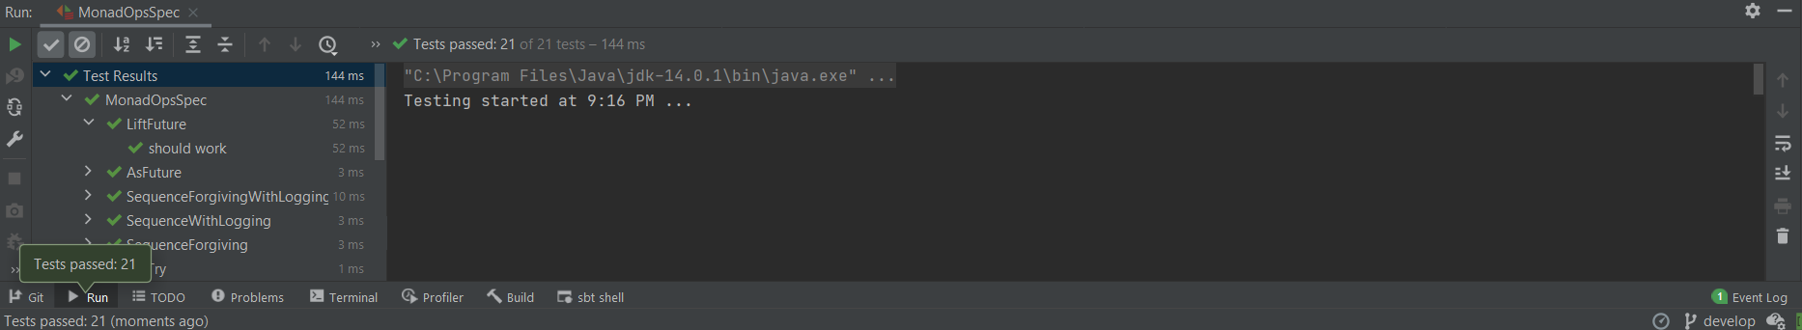

**WebCrawlerSpec**

